
PT1/CSAK/1123/A 01-MAY-2023
PERIODIC TEST - I (2023-24)
Subject: COMPUTER SCIENCE(Answer Key)  Grade: XI |  | Max. Marks: 35  Time: 1 Hr 15 Mins
 | SECTION A |  | (9)
1. | d) 4 |  | 1
2. | b) ASCII |  | 1
3. | String |  | 1
4. | c) None of the above
5. | b) Step 2, Step 1, Step 4, Step 3 |  | 1
6. | False |  | 1
7. | b) A2 |  | 1
8. | d) Images:Vector |  | 1
9. | c) A is True but R is False |  | 1
 | SECTION B |  | (12)
10. | Literals mean constants i.e. the data items that never change value during a program run. Python allow five types of literals :  - String literals  - Numeric literals  - Boolean literals  - Special literal (None)  - Literal collections like tuples, lists etc.  (1 mark for explanation, 1 mark for types) |  | 2
11. | The Standard Data Types in python are.  (a) Numbers  (b) String  (c) List  (d) Tuple  (e) Dictionary |  | 2
12. | 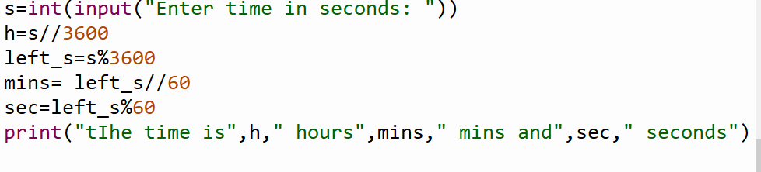  (1 mark for i/o, 1 for calculation) |  | 2
13. | 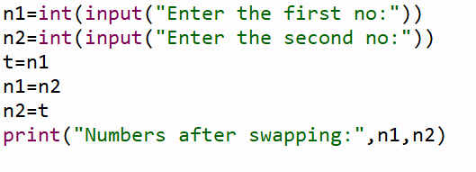  (1 mark for i/o, 1 mark for swapping) |  | 2
14. | 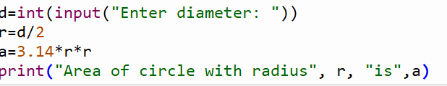  (1 mark for i/o, 1 for calculation) |  | 2
15. | 111 101 001 – octal to binary (1 mark)  0001 1110 1001 -> (1E9)₁₆ (1 mark) |  | 2
 | SECTION C |  | (6)
16. | 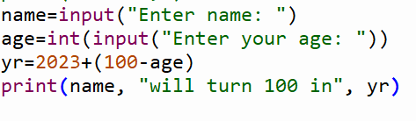  (1 mark for input, 1 mark for output, 1 mark for calculation) |  | 3
17. | 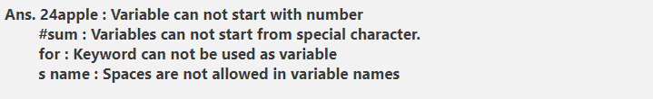 |  | 3
 | SECTION D |  | (8)
18. | 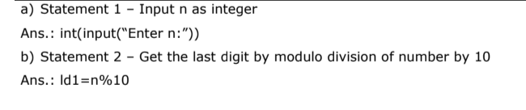  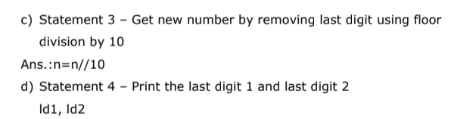 |  | 4
19. | Do the following Conversions:  - (BCAI)₁₆ - (1011110010100001)₂  - (2306)₈ - (10011000110)₂  - (4052)₁₀ – (FD4)₁₆  - (1111000)₂ – (120)₁₀ |  | 4
***

